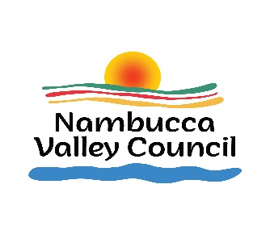
NAMBUCCA VALLEY COUNCIL

APPLICATION FOR SECTION 356
DONATION PROGRAM

2023/2024 FINANCIAL YEAR
File: SF3334

Name of applicant, organisation or group applying for financial assistance:

(Please provide the correct name of any legal entity, including any trading names, ABN, ACN, BN or other registration number as shown on the Australian Securities and Investment Commission website http://www.asic.gov.au )

Street and postal address:

Contact name:

Telephone number: Email:

Description of organisation or group: _____________________________________________________________________________________________________________________________________________________________________________________________________________________________________________________________________________________________________________________________________________________________________________
(Please include the purpose of the organisation, or group, current activities and the current number of members)

Applicant’s viability: (Attach the most recent financial statement if available)
____________________________________________________________________________________________________________________________________________________________________________________________________________________________________________________________________________________________________

Amount of financial assistance applied for: $ (excl GST)
(Request amount is capped at a maximum of $500.00 as per Council’s Donations Policy)

Proposed use of funds: (Attach supporting documentation if space not adequate)

____________________________________________________________________________________________________________________________________________________________________________________________________________________________________________________________________________________________________

How will the community benefit from allocation of the funds by Council?

____________________________________________________________________________________________________________________________________________________________________________________________________________________________________________________________________________________________________

If applicable, in what way(s) do you consider the proposed beneficiaries of the funds are disadvantaged?
_____________________________________________________________________________________________________________________________________________________________________________________________________________________________________________________________________________________________________________________________________________________________________________

How does the project contribute to the priorities of the Nambucca Shire Community Strategic Plan?
_____________________________________________________________________________________________________________________________________________________________________________________________________________________________________________________________________________________________________________________________________________________________________________

Is your organisation providing any of its own funds for the proposed project?

Yes If yes please advise amount $ (excl GST).

No

APPLICANT(S) DECLARATION:

- The information provided in this application is true and correct.
- The applicant is a not-for-profit organisation.
- The financial assistance, if provided, will not be used for private gain.
- I/We are not already receiving financial assistance from Council.

Signed for and on behalf of: _________________________________
(Name of Applicant/Group)

Signature:

Date:

Applications must be lodged with Council by post at PO Box 177 Macksville NSW 2447 OR by email to council@nambucca.nsw.gov.au no later than 4.30 pm on 1 March 2024. Late applications will not be accepted.
Council reserves the right to use the grantee for publicity/promotional purposes.
Office Use Only:

